**Final Assessment Java Full Stack**

Nishevidhaa M

46.

**package** Incedo;

**import** java.util.*;

**public** **class** Anagrams {

**private** **static** **void** printAnagrams(String arr[])

{

HashMap<String, List<String> > map

= **new** HashMap<>();

**for** (**int** i = 0; i < arr.length; i++) {

String word = arr[i];

**char**[] letters = word.toCharArray();

Arrays.*sort*(letters);

String newWord = **new** String(letters);

**if** (map.containsKey(newWord)) {

map.get(newWord).add(word);

}

**else** {

List<String> words = **new** ArrayList<>();

words.add(word);

map.put(newWord, words);

}

}

**for** (String s : map.keySet()) {

List<String> values = map.get(s);

**if** (values.size() > 1) {

System.***out***.print(values);

}

}

}

**public** **static** **void** main(String[] args)

{

String arr[]

= { "eat", "tea", "tan", "ate", "nat" };

*printAnagrams*(arr);

}

}

Expected Output:

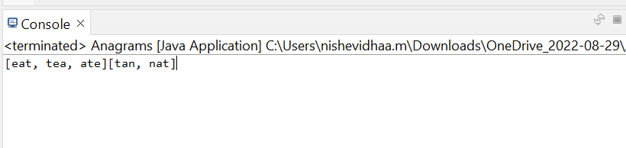

47)

**package** Incedo;

**public** **interface** Window {

**void** paint();

}

**public** **class** PMWindow **implements** Window {

@Override

**public** **void** paint() {

System.***out***.println("This is PMWindow classs");

}

}

**public** **class** MotifWindow **implements** Window {

@Override

**public** **void** motif() {

System.***out***.println("This is a Motif window class");

}

}

**public** **interface** scrollbar {

**void** motif();

}

**public** **class** PMScrollbar **implements** scrollbar {

@Override

**public** **void** motif() {

System.***out***.println("This is PM scrollbar class");

}

}

**public** **class** MotifScrollbar **implements** scrollbar {

@Override

**public** **void** motif() {

System.***out***.println("This is ");

}

}

**public** **interface** WidgetFactory {

Windows createwindows();

Scrollbar createscrollbar();

}

**public** **class** MotifWidget factory **implements** Widgetfactory {

Windows createwindows();

Scrollbar createscrollbar();

}

**public** **class** PMWidget factory **implements** Widgetfactory {

Windows createwindows();

Scrollbar createscrollbar();

}

**public** **class** Final {

}

48 )

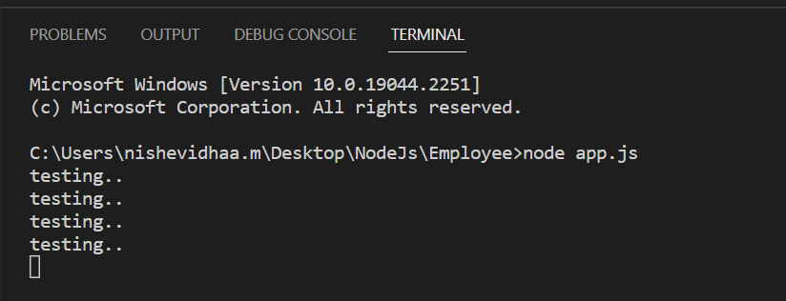

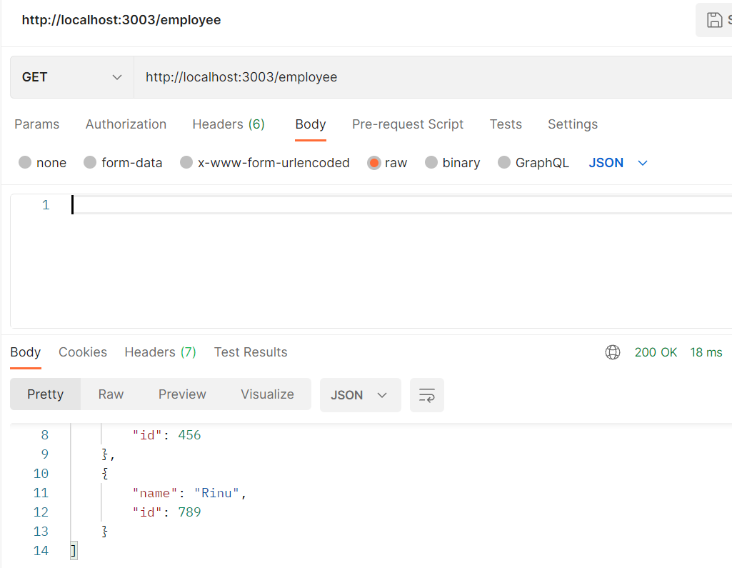

50. A)

import {useState} from 'react';

const App = () => {

  const [num, setNum] = useState(0);

  function randomNumberInRange(min, max) {

    return Math.floor(Math.random() * (max - min + 1)) + min;

  }

  const handleClick = () => {

    setNum(randomNumberInRange(10007, 500007));

  };

  return (

    <div>

      <h2>My Magical number is {num}</h2>

      <button onClick={handleClick}>Magic Number</button>

    </div>

  );

};

export default App;

Expected Output:

